## Drawing Conventions and Standards

Good communication is essential for any interior design project’s success. Within the interior design industry, graphic communication plays an important role in communicating the design, its features and details, to ensure its proper implementation.

Drawing conventions and standards for technical drawings exist to allow a universal approach across different disciplines (architecture, interior design, engineering, etc.) and improve the coherence and cross-referencing of all drawings. It is a formal and precise way to communicate your design.

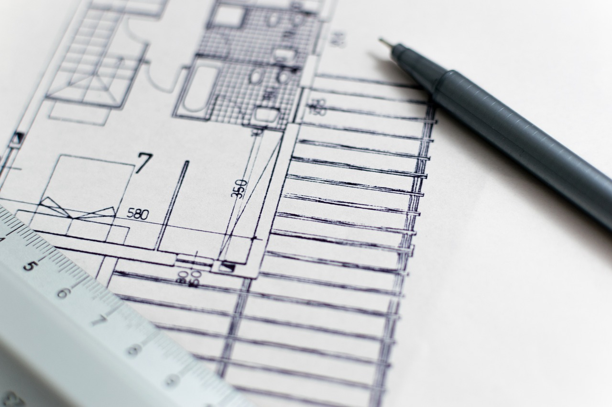

Fig 1. Pixabay (n.d.) Technical drawing

Applying the correct conventions and standards to your drawings will ensure you communicate your ideas effectively and unambiguously.

Using these universal symbols in your practice will also help in reducing time in understanding and coordinating different drawings and will also minimise errors.

Below, you’ll find examples of some of the conventions and standards applicable to any interior design practice.

## Drawing scale

Each architectural and interior design project must contain a set of different technical drawings. To ensure each drawing fits on a drawing sheet, the designer must consider the size of the drawing sheet and the scale at which a specific drawing is shown. For example, a site plan should show a larger scale than a floor plan since the area of a site plan is much bigger.

Drawing something ‘to scale’ means scaling down every item (by the same amount) in the drawing to ensure it fits on the sheet of paper. It is challenging, if not impossible, to fit a drawing of an interior design space or item of furniture at the scale of 1:1 on an A4 or A3 sheet of drawing paper, so each drawing must be scaled down. The most common scales used in interior design are 1:50 and 1:20. A scale of 1:20 means the object drawn is twenty times larger in real life. On a scale of 1:50, objects drawn are fifty times larger in real life.

A designer can use a scale ruler to avoid calculating the length when something is drawn. It's important to remember that no matter what scale is used, all items within one drawing must be drawn to the same scale.

| **Drawing Type** | **Scale** |
| --- | --- |
| Site plan | 1:100 up to 1:250 |
| Floor plan | 1:20 or 1:50 |
| Elevation | 1:20 or 1:50 |
| Section | 1:20 or 1:50 |
| Detail | 1:10 or 1:5 depending on size of object |
| Lighting and electrical | 1:20 or 1:50 |

The scales we use in Interior Design projects, will depend on the content of the Drawings we are producing. If we are working on a room, we usually work at a scale of 1:50, 1:25 or 1:20, depending on the dimensions of the room and the paper size we are using. If we are working on bespoke furniture, or other detail drawings, the scales used are typically 1:10, ,1:5, or even 1:2, 1:1, depending, again, on the size of the item we are drawing and the required details. A technical floor plan can then be used for a furniture layout and an electrical and light layout. In addition, a ‘detail’ drawing might be needed for a given area or element.

## Technical drawing equipment

Generally, the same principles for technical drawing apply whether they are produced manually or digitally. However, different tools are required in each case. For a manually created technical drawing, the following equipment is needed:

* Drawing board, parallel bar, and
* Set squares (45o and 60o angled ones)
* Paper and or masking tape
* Mechanical Pencils (HB, or B2 nibs) and eraser
* Technical drawing pen set
* Scale ruler (scales 1:2 - 1:75)
* Drawing compass or circular template



Fig 2. Pixabay (n.d.) Example of tools required for drawing

### Drawing Board, T-Bar, And Set Squares

For the interior design course, an A3-sized board is recommended but you can purchase an A2 board or larger if you wish. The drawing board should contain a built-in parallel bar that can move horizontally up and down. The parallel bar is fitted at a perfect right angle to the side of the drawing board, allowing easy movement and the creation of a perfect horizontal line. To achieve straight vertical lines, sit the set squares onto the T-Bar, so as to achieve a clear vertical line. 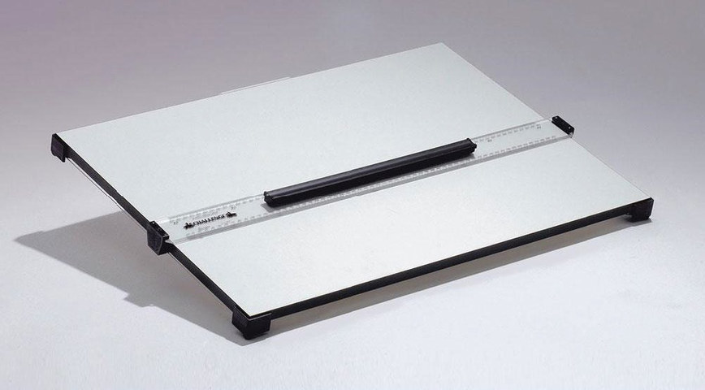

Fig 3. Blundell Harding (2020) *Challenge Drawing Board* [photograph]

#### SCALE RULER

The scale ruler is widely used to convert the actual size of a space to a smaller size. It allows you to accurately represent a floor plan, elevation, etc., on a drawing sheet. Using a scale ruler, therefore, reduces the likelihood that errors will be made. Typically, the scale ruler is 30cm in length; ideally, it should have a variety of scales, In Interior Design, we usually use a scale ruler that includes scales from 1:10 - 1:100.

#### PAPER AND SCOTCH OR MASKING TAPE

Use the most appropriate paper size for an architectural or interior design technical drawing. For a smaller project, or (more commonly) an A3 sheet size. This includes the floor plan for a room in a domestic property. In general, the larger the project, the larger the sheet size. Fig. 2 shows paper sizes ranging from A4 to A0 and their corresponding sizes in mm.

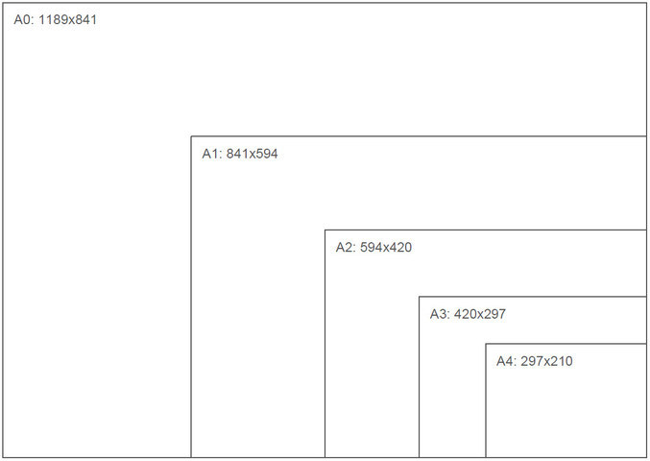

Fig 4. Paper sizes A4 – A0

You should also consider the quality of the paper for a technical drawing. Paper quality is measured in ‘gram per square metre’ (GSM); the higher the number, the heavier the paper. Paper of around 90gsm can be used for sketching. For technical drawing, 200gsm paper can be used. For something like watercolour rendering, a heavier weight of 300gsm will perform better.

To ensure that the drawing board's paper is secured, you should use tape (such as scotch or masking tape) to adhere it to the board. Place the tape at each corner of the paper and gently remove it when your technical drawing is complete.

#### PENCIL AND ERASER

If producing your technical drawing manually, use a pencil to draw everything in first. By drawing everything in pencil, you can erase errors and make amendments. Draw each pencil line lightly. A clutch or mechanical pencil is best, but you can also use a standard pencil. When you have completed your technical drawing, carefully ink the lines using a pen and erase the pencil marks.



Fig 5. Pixabay (n.d.) Clutch pencil

The HB scale indicates how light or heavy the pencil is. H stands for heavy, and B stands for black. A B grade means the pencil has more graphite and will be darker and a smidge more easily. An H grade means the pencil has more clay, will be lighter, and will not smudge as much.

There are different grades of hard and soft graphite on this scale. The higher the number, the harder or softer the pencil. For example, a 9H pencil is much harder than a 2H pencil, and a 9B pencil is much softer than a 2B pencil. HB is in the middle of the scale.

A 2H pencil is the most suitable for drawing clean, sharp construction lines in a technical drawing.

#### TECHNICAL DRAWING PEN SET

Drawing pens are applied to each finished line and lettering in a manually produced technical drawing. There are both refillable and disposable drawing pens available. A pen set will generally contain different nib sizes, producing a range of line widths to create a drawing. Below are the recommended line widths for each aspect of a manually produced technical drawing:

* The heaviest lines are used for the sheet border and each main construction element, including the external and internal walls on a floor plan
* Medium lines are used for a secondary object, including an element like a door or a symbol like a pendant light.
* Light lines are used for smaller, finer detail on any type of a manually produced technical drawing

#### DRAWING COMPASS AND CIRCULAR TEMPLATE

A drawing compass is used to draw an accurate arch or circle. Use a compass or circular template for a floor plan to represent the door swing correctly. A drawing compass is preferred since it is more precise. In addition, you can draw all electrical and lighting symbols with the help of a drawing compass or circular template.

A range of architectural drawings and furniture symbol templates are available for use on a technical floor plan drawing. They are not explicitly required and simply represent the generic size for a specific piece of furniture or fixture. If using a template, ensure it is at the same scale as your drawing. For example, use a 1:50 furniture template for a technical floor plan drawing completed at a scale of 1:50.

SETTING UP YOUR DRAWING BOARD

* Remove the T-Bar, so that you have access to the board itself.
* Take your A3 paper and place it on your board, so that it sits onto the bottom frame, making sure the left side of the paper is also perpendicular to the side of the drawing board.
* Using a small bit of masking tape, secure the top left hand side of the paper to the drawing board.
* Using the back of your hand, stroke the paper down to the opposite corner, this ensures there are no air bubbles between your paper and the drawing board.
* Secure the opposite corner with another small piece of masking tape.
* Repeat the above process for the other two opposite corners.
* Return the T-Bar to the drawing board and secure it in place.

You are now ready to start drawing!

## Drawing sheet and title panel

#### THE SHEET BORDER

Each drawing sheet should contain a border and title panel. Draw the border 1cm or 10mm from the sheet's edge. For a manually produced technical drawing, draw the border in pencil and then ink it using the boldest pen line (nib size 0.8).

Allocate space for a title panel and legend by drawing another line 8cm from the right of the sheet and subdividing the title panel area. Each increment in the title panel should measure 1cm or 1.5cm.

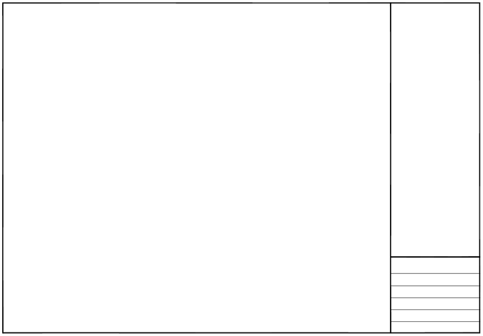

Fig 6. Drawing sheet and allocation of space for a title panel and legend

#### THE TITLE PANEL

Information must be recorded on the drawing sheet in the title panel for each technical drawing. The amount of detail needed depends on the size and type of the design project. The title panel should contain enough information to ensure that the technical drawing is clearly identifiable. The following is the minimum amount of detail the title panel should include:

* **Drawing name:** the type of drawing shown on the drawing sheet. For example: Master Bedroom Floor Plan
* **Drawing number:** this is needed to manage a design project and cross-reference a technical drawing and a specification sheet. An example is: ID 01
* **Date:** the date of construction of the technical drawing
* **Scale:** each technical drawing is drawn at a given scale and on a given sized sheet of paper. Both should be recorded here (e.g. 1:50 @ A3)
* **Client:** details about the client, including their name and contact information, is a requirement
* **Designer:** Where applicable for a technical drawing, the name of the person drawing up the floor plan or elevation and the design firm's name. For example: Sophia Johnson: Interior Design Academy

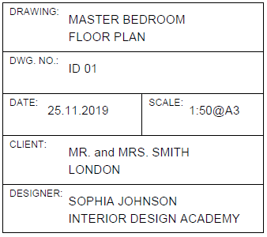

Fig 7. Example of a completed title panel

You might also need to record electrical, lighting and furniture information on the technical drawing sheet. Typically, that detail is recorded in a legend positioned above the title panel.

#### DRAWING SHEET COMPOSITION

The position of the title panel can change depending on the amount of space available on the sheet. The most common format is where the title panel and legend are positioned on the right-hand side of the sheet.

Once the sheet border and title panel are drawn, the main drawing element can be created. Determine a centre point by drawing a diagonal line from each top corner of the drawing area to the bottom corner. Note: Each diagonal line should be drawn using a light pencil that can be erased later.

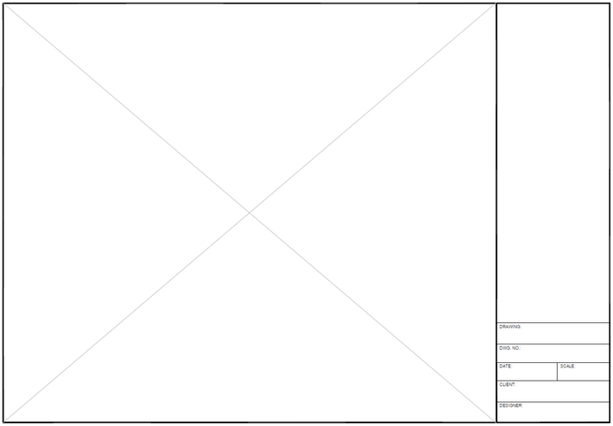

Fig 8. The centre point of the drawing area indicated

Next, position the drawing by taking the overall length and width of the floor plan or elevation. In the example (Fig. 8), the floor plan is drawn at a 1:50 scale, and the overall length of the room is 5500mm. Using the scale ruler, position 2250mm on the centre point and draw a horizontal line from 0-5500mm. Alternatively, mark the start and end points.

The overall width of the room is 4000mm. Use the scale ruler to position 2000mm on the centre point and draw a vertical line from 0-4000mm, or alternatively, simply mark the start and end points.

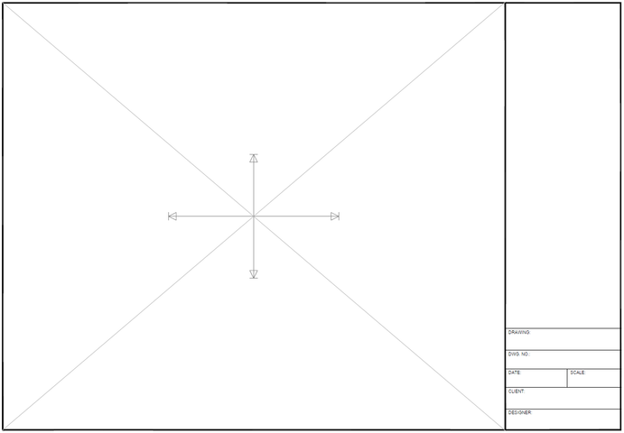

Fig 9. Horizontal and vertical lines measured and drawn from the centre point

Next, draw the outline of the space. Using the set square, draw each vertical line through the endpoints on the horizontal axis and then use the parallel bar to draw each horizontal line through the endpoints on the vertical axis. The lines should join to form a rectangular shape that provides the basic outline for the floor plan drawing.

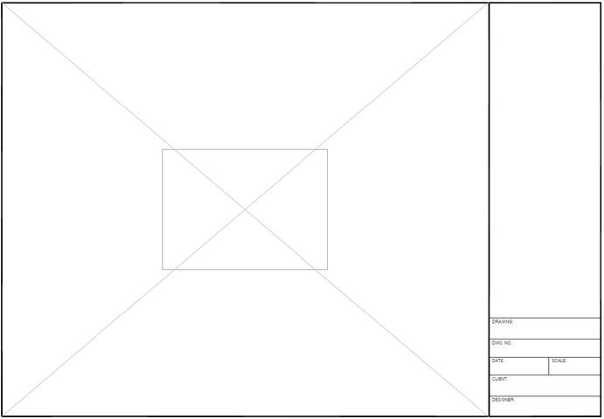

Fig 10. The outline for the floor plan

If using a larger drawing sheet, you might be able to put more than one drawing on the same sheet, but you must carefully consider its composition. Locate the drawing with the greatest priority towards the top left corner of the drawing sheet.

Whatever arrangement you choose, it is essential to maintain equal spacing between each drawing. Remember to allocate enough space for annotations and dimension details.

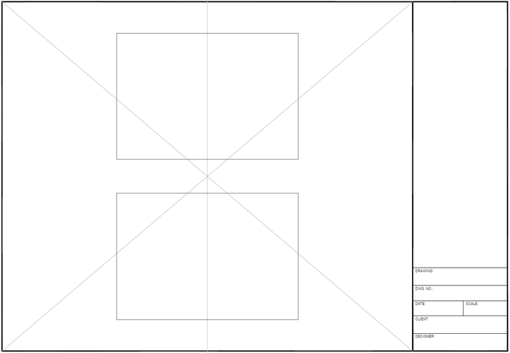

Fig 11 (a). Different compositions for a drawing sheet

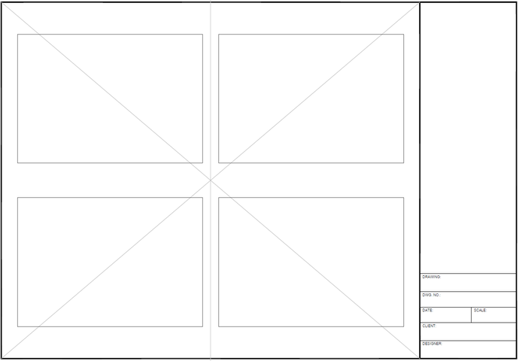

Fig 11 (b). Different compositions for a drawing sheet

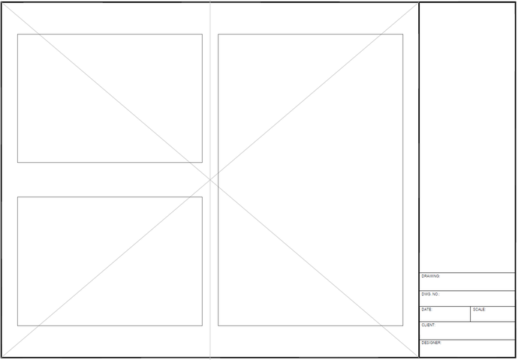

Fig 11 (c). Different compositions for a drawing sheet

## Adding a Legend to your Technical Drawing

In Technical Drawings, we use a legend in order to explain the various symbols we are using and the meaning of each one. They type of symbol used will depend on the nature of the Technical Drawing and the scope and purpose of it. For example, in a Lighting Plan, the symbols explained and included in the Leged will refer to the electrical symbols used on the Technical Drawing.

(Add example of Technical Drawing with Legend)

## 

## 

## Abbreviations and symbols

Technical drawings use standard abbreviations and symbols. Here are some of the common abbreviations and symbols used on technical drawings.

| **Abbreviation** | **Meaning** | **Abbreviation** | **Meaning** |
| --- | --- | --- | --- |
| CH | ceiling height | HW | hot water unit |
| D | door | INSUL | insulation |
| DG | double glazing | M | metre |
| DIA | diameter | MSB | master switch board |
| DIM | dimension | SD | sliding door |
| DWG | drawing | SHR | shower |
| EL | elevation | TEL | telephone |
| FA | floor area | TV | television |
| FP | floor plan | VENT | ventilation |
| FFL | finished floor level | VP | vent pipe |
| GL | glass | W | window |
| GM | gas metre | WC | water closet |
| HTR | heater | WR | wardrobe |

**North point:** placed at the top right-hand corner of the drawing area on a technical floor plan drawing. The arrow of the north point



Fig 12. North arrow

**Door and window tag:** a reference for a specific door or window on a technical floor plan drawing. The top line references a given door or window and the number allocated to the specific one (i.e. D01 and W01). The first measurement under each is the distance from the floor to the **bottom** of the door or window, and the second is the distance from the floor to the top.

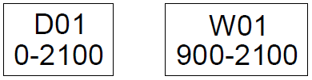

Fig 11. Tag

## Door symbols

The correct door symbol should be drawn for technical plans and elevation drawings. If a door is hinged, it is represented in an open position on a floor plan and with a dashed line on an elevation. Here are some of the most common types of door symbols used in plan and elevation views:

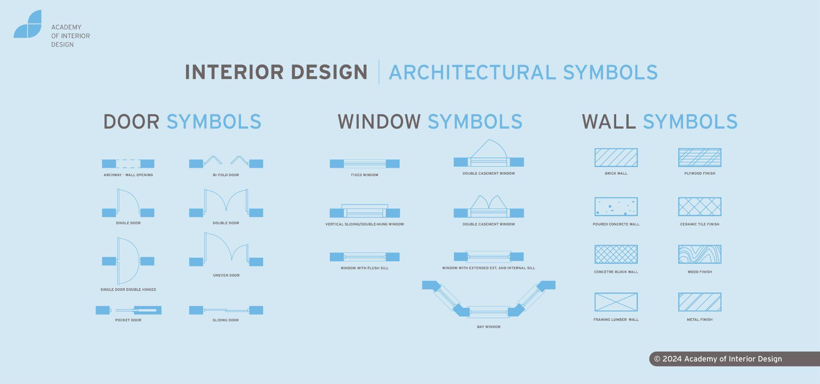

Fig 12. Doors in plan view

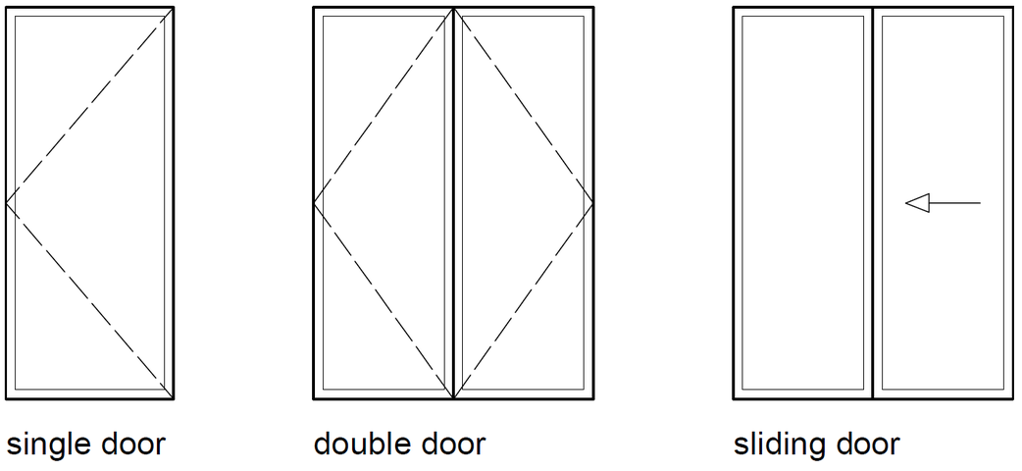

Fig 13. Doors in elevation view

## Window symbols

The correct window symbol should be drawn for both a technical plan and elevation drawing. The outline of the frame and the glazing are illustrated both on a floor plan and elevation. Here are some of the most common types of window symbols used in plan and elevation views:

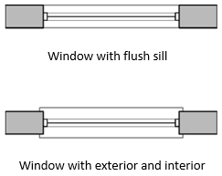

Fig 14 (a). Windows in plan view

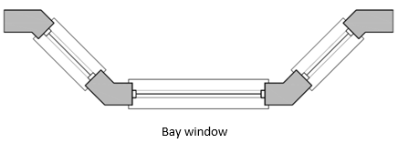

Fig 14 (b). Windows in plan view



Fig 14 (c). Windows in plan view

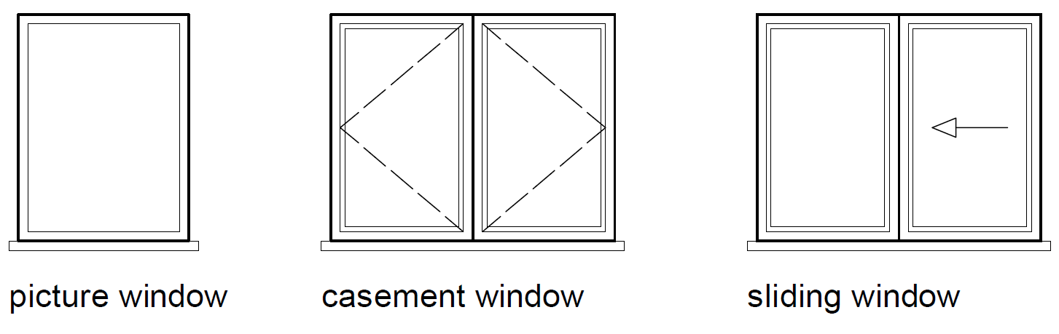

Fig 15. Windows in elevation view

## Line symbols

Different line types can convey a variety of information within a technical drawing. Here are the most common line types:

* **Construction line:** light line for marking the outline of the drawing. It is usually drawn with a light pencil that is erased later
* **Drawing line:** heavier line for inking in the drawing
* **Break-line:** medium line used when only a part of the drawing is shown, or the extent of the whole drawing would go beyond the paper size used
* **Hidden line:** light line demoting something overhead on a plan (e.g. an arch or a beam) and also used if an object is hidden by another object
* **Centre line:** light line illustrating the centre of an object or drawing
* **Dimension line:** light line used to record dimensional information
* **Leader line:** another light line drawn to highlight something specific on the drawing
* **Cutting plane:** heavier line indicating a section cut through the plan. They are accompanied by a section drawing, showing the way the item has been cut and the details within the cut.

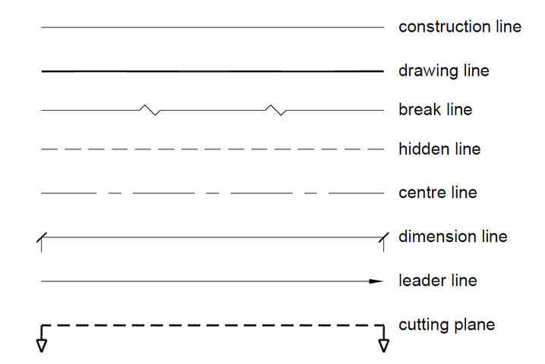

Fig 16. Line types used for technical drawing

## Hatching

You should represent each material cut in a technical floor plan or section drawing with a standard hatch or symbol. Here is a list of the most common hatching used for technical drawing:

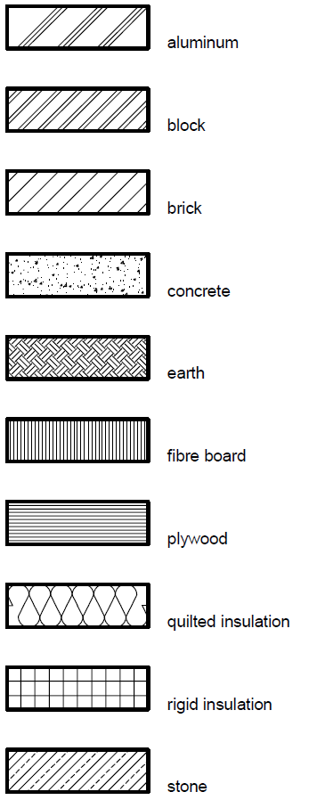

Fig 17. Hatching symbols used for technical drawing

## Dimensioning

Dimensional detail is included in each type of technical drawing to ensure that the information on the drawing can be read faster. Dimensional information eliminates the need for everyone involved in the project to measure each drawing line. In turn, the inclusion of dimensional detail prevents errors regarding sizing.

The **dimension line** consists of a straight line with a perpendicular line (i.e. a **leader line** drawn at either end). The dimension line should be drawn parallel to whatever the measurement is referencing, and the leader line should be drawn perpendicular to the dimension line. The dimensional and the leader lines are drawn using the same pen nib size. In addition, the dimensional and the leader lines should meet, but the leader line should not touch the drawing itself.

The start and end points of the dimension line in Interior Design and Architecture are shown usingan architectural tick. The most common are shown in Fig 18. Closed arrows are usually used in the engineering industry.

For a technical drawing, the standard unit of measurement is a millimetre. The size is most commonly written above the dimension line.

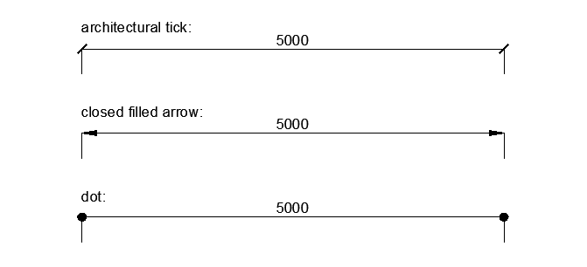

Fig 18. Arrows used for technical drawing

## 

## Hierarchy of dimension placement

In interior design, the dimensional detail for the internal space of a room must be recorded on a technical floor plan drawing. At a minimum, note the overall length of each main structural element. If there are no features or openings in a wall, then record the overall length. However, if there is a feature or opening (e.g. chimney breast or window), then the length of each element should also be recorded.

If more than one overall dimension line is required, then a hierarchy of dimensional placement should be implemented. Note the overall length furthest out from the technical floor plan drawing and then place a more detailed breakdown below the overall length, as illustrated in Fig. 19 and Fig. 20.

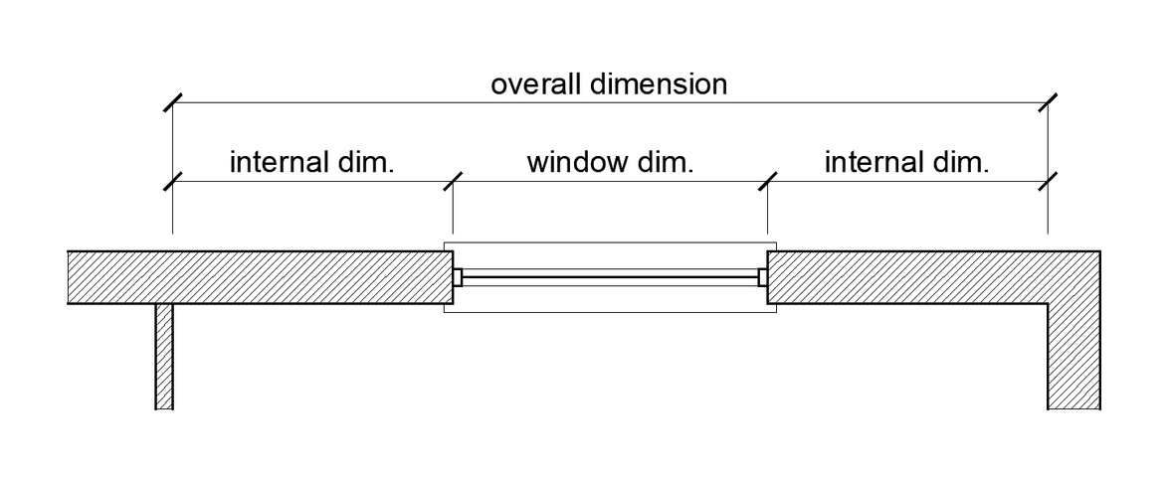

Fig 19. Hierarchy of dimensional placement explained

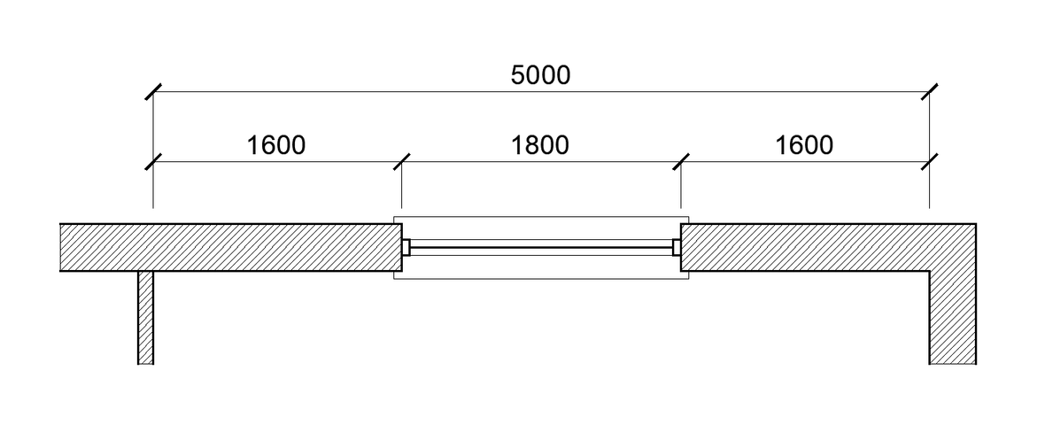

Fig 20. Hierarchy of dimensional placement

Note: The same principle applies to a technical elevation drawing where each height measurement should be recorded.

#### ANGLED DIMENSIONS

For an angular dimension, it is best practice to record the vertical and horizontal measurements using a hidden line. The angular measurement should also be shown.

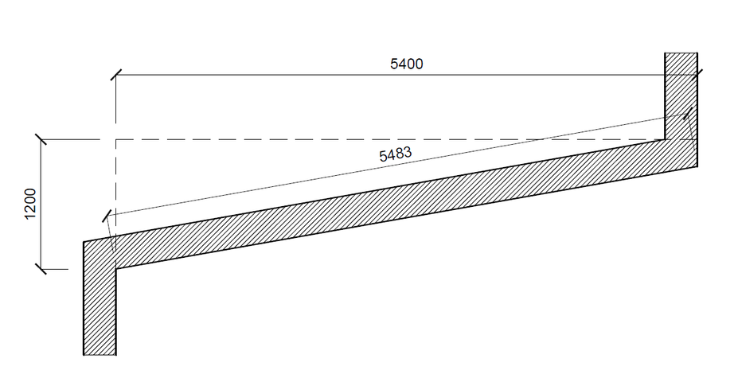

Fig 21. Angular dimension

### 

#### CURVED OR CIRCULAR DIMENSIONS

To represent a curved flooring pattern or a curved window, record a curved dimension as shown in Fig 22. In addition, record the location information with the actual curve or circle measurement.

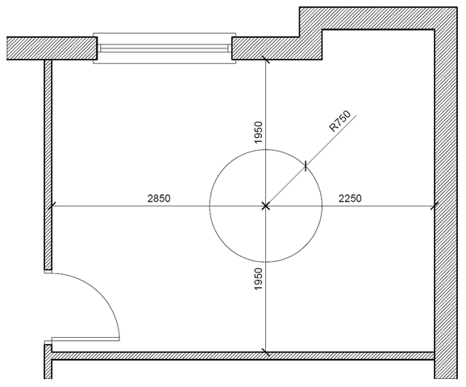

Fig 22. Circular shape including locational dimensions and radius measurement

## 

## Lettering

For each technical drawing, add text to the title panel and legend and annotations and dimensional information to the drawing itself. Both the hand-written lettering and numbering must be legible as misinterpretation of information can lead to costly mistakes being made on a design project.

Draw a guideline in pencil to achieve neat and precise lettering on a manually-produced drawing. A light pencil guide can ensure that the lettering is uniform. Next, write the text in capital lettering using a pencil. Then ink and erase all pencil marks.

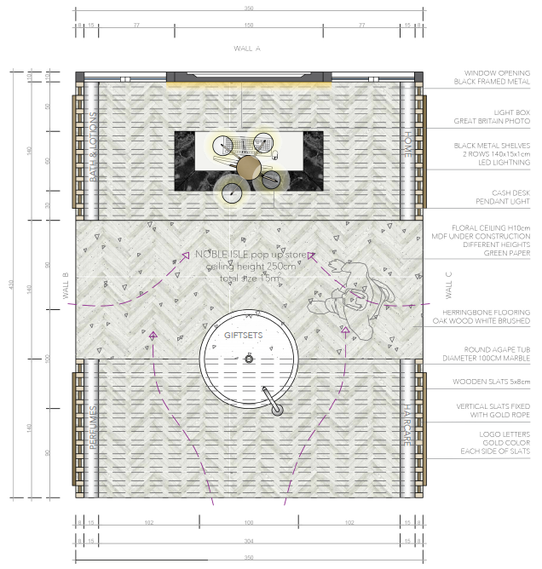

Fig 23. Layout plan – student example with annotations and dimensional details

## Types of Technical Drawings:FLOOR PLANS

As we have learnt from previous assignments, interior designers would create floor plans to communicate technical details such as the lengths and widths of a space. Floor plans are 2-dimensional technical drawings which do not show any depth. Technical floor plans are drawn to scale and are used to represent a view from above looking down into the space. You will note within floor plans, we are able to see the thickness of walls, the placement of windows, doors, fireplaces etc. Basic drawing conventions are applied, and drawing tools are used to ensure a neat, precise drawing which communicates valuable information about the technical details of the space.

When drawing the floor plan, we need to imagine the space sliced half horizontally, about 1m above the bottom of the floor line. This now will reveal the floor plan. As seen in the below example, if we imagine this space has been sliced in half at 1m above the floor level, we can see that we would cut through solid walls and doors and windows. We use the door and wall symbols as previously discussed to show the “cut” through door openings and window openings.

Floor plans can communicate the existing space (as-built drawings). We can also plan the space and positioning of furniture (furniture layouts), specify flooring (floor finish layouts), and communicate other interior design elements. A floor plan is thus a vital tool to use when sharing your designs.

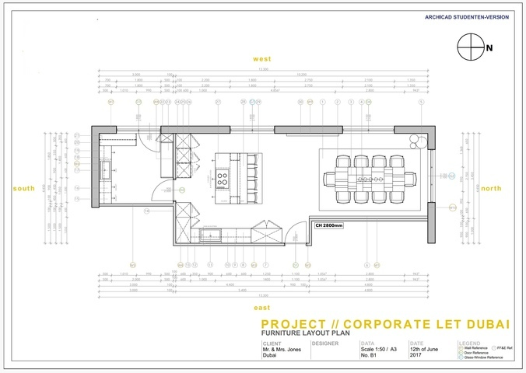

Fig 24. Example of a floor plan

**Important tips to keep in mind when drawing a floor plan:**

* Use an appropriate choice of drawing sheet size depending on the chosen scale of the drawing
* Use an appropriate scale – make sure you have space for your dimensions and title block
* Include a neat border and title panel with the required information
* Include a north point, typically positioned in the top right-hand corner of the drawing. A north point aids in communicating the direction of North in relation to our space. This is useful to know as it helps us understand where light enters a space, for example
* Each wall should receive a well tag (e.g. A and B). This helps us cross-reference with elevations so we understand which elevation matches each wall on the floor plan
* Make sure to show all window and door openings using the correct symbols
* Don’t forget all relevant dimensional information; both smaller detailed dimensions and overall dimensions are important
* Once you have finished drawing in pencil, and are happy with the final drawing, be sure to ink in the floor plan using a pen. Don’t forget to work with the correct line weights allocated to each element
* A wall hatch should be added
* Each window and door should be numbered correctly (e.g. D01: 0-2100)
* Include the name of the room and ceiling height noted underneath the floor plan drawing for a clean, uncluttered finish

#### Ceiling components and reflected ceiling plans

A Reflected Ceiling Plan, also named as (RCP), is a technical drawing that shows the items located on a ceiling of a space/room.

Common information included in RCPs is:

* Ceiling heights
* Specification on the type of ceiling (conventional, suspended, etc.)
* Specification for the ceiling finishes
* Lighting locations and their types
* Bulkheads, Beams or any decorative and structural features that result in ceiling height changes
* Heating Ventilation and Air Conditioning (HVAC) supply and return air vents
* Duct locations and heights were visible.
* Security systems, including alarms, sprinklers, sensors, security camera locations and security monitors.

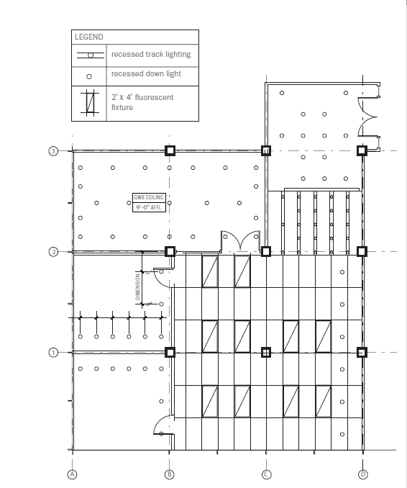

Fig. 25 Grimley, Chris, and Mimi Love (2007) Reflected Ceiling plans [digital image]

**Note:** *Mind the difference between reflected ceiling plans and electrical plans. RCP will only show information related to or included within the ceiling structure, while an electrical plan will show every electrical feature of the room, whether connected to the ceiling, walls or flooring.*

### ELEVATIONS

As we learned from previous assignments, technical elevations are 2D dimensional drawings communicating essential information, such as the heights within a space. These drawings are drawn to scale and represent the interior wall surface or exterior façade. An elevation is a flat 2D representation of what one sees when looking at a particular wall. An elevation can communicate details of windows, doors, fireplaces, etc., clearly. Basic drawing conventions are applied, and drawing tools are used to ensure a neat, precise drawing which communicates valuable information about the technical details of the wall surface.

Unlike the floor plan, a horizontal cut through the space, elevations communicate a particular wall surface. The elevations allow us to measure and specify items on the walls or within 1m of each wall shown. We can establish window and door measurements and show the location of pictures, sofas, chairs, lighting and other items positioned on that particular surface where required. We could also use an elevation to communicate a particular painted design or specific wall finish.

In the below example, you will note furniture has been included, and although the bed would extend beyond the 1m limit, it would not make sense to “cut” this bed in half at 1m from the wall, so here, the entire bed is shown as this makes more sense.

If you are only communicating the wall finishes of the space, there would be no need to show the furniture.

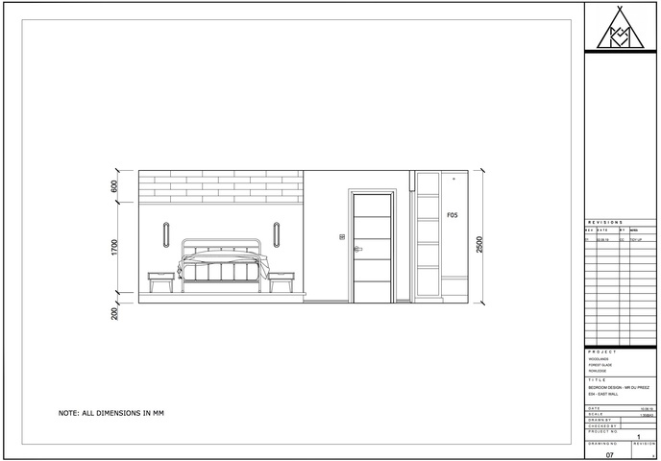

Fig 26. Example showing an elevation which includes furniture

**Important tips to keep in mind when drawing an elevation:**

* Use an appropriate choice of drawing sheet size depending on the chosen scale of the drawing
* Use an appropriate scale – make sure you have space for your dimensions and title block
* Include a neat border and title panel with the required information
* Each wall should receive a well tag (e.g. A and B). This helps us cross-reference with elevations so we understand which elevation matches each wall on the floor plan
* Make sure to include all windows, doors, electrical sockets and/or switches present on the elevation as we see them
* Don’t forget all relevant dimensional information; both smaller detailed dimensions and overall dimensions are important. Remember, an elevation should focus on including only vertical height dimensions. Only include length dimensions of finer details that you are not able to place on the floor plan
* Once you have finished drawing in pencil, and are happy with the final drawing, be sure to ink in the elevation using a pen. Don’t forget to work with the correct line weights allocated to each element
* Where necessary, you may need to include annotations with a leader line to identify everything on the drawing if required
* Include dashed lines to represent the way a window/door will open
* Levels can be indicated where relevant
* Grid or section line indicated where needed
* Note: no depth should be shown on a technical elevation drawing

### Furniture Design

Furniture Design refers to any custom-made interior furnishes tailored to the needs of your design. This refers to any piece of work, whether it is large or small, that is fabricated for a specific project/room. This can include shelving systems, staircases, custom kitchen cabinets, etc. These can be produced using various materials, such as wood steel, aluminium etc.

Furniture Design is especially useful if you have a specific need or a uniquely shaped space that is not compatible with the standard off-the-shelf options. Furniture Design will, in this case, offer a more holistic approach to the design and allow you to maximise the space.

Depending on the design and nature of your project, the Technical drawings of furniture should include the minimum of:

* A plan of the customized piece
* All elevations of the piece
* Sections showing the interior features (i.e. the interior shelving/compartments)
* Details of the piece to ensure its good manufacturing. These can include the opening systems, the junction at the corners, upholstering details, etc;
* A complete legend referring to all materials to be used and their location within the design piece (ie. specifications)
* All relevant dimensions

Below you will find some examples of technical drawings for custom joinery.

Fig .27. BAID, Drawings for custom-made display unit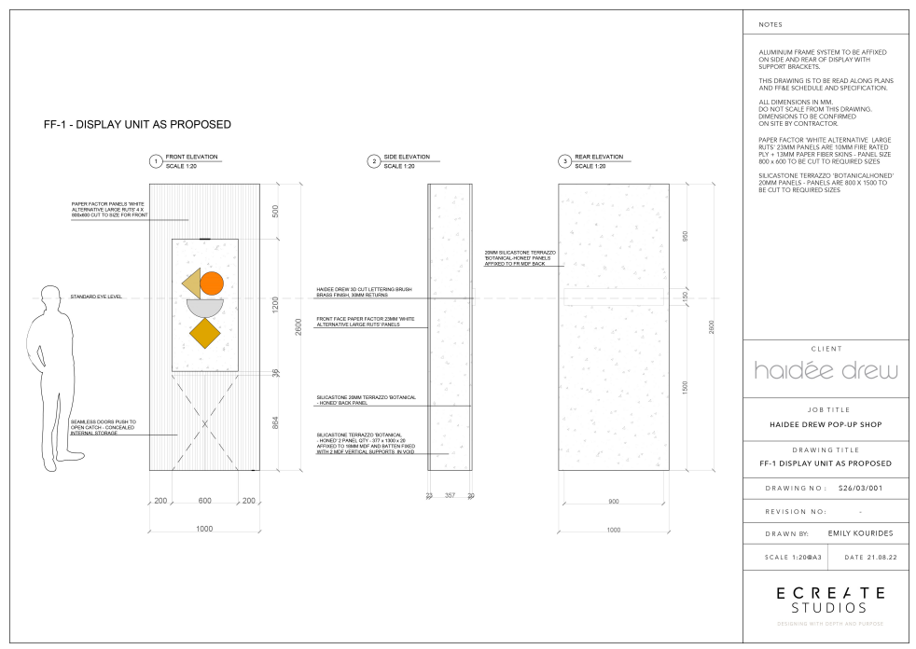

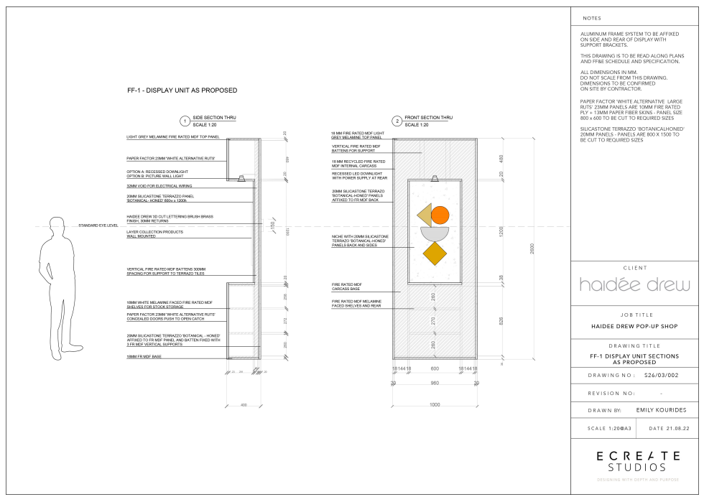

Fig .28 BAID, Drawings for custom-made display unit

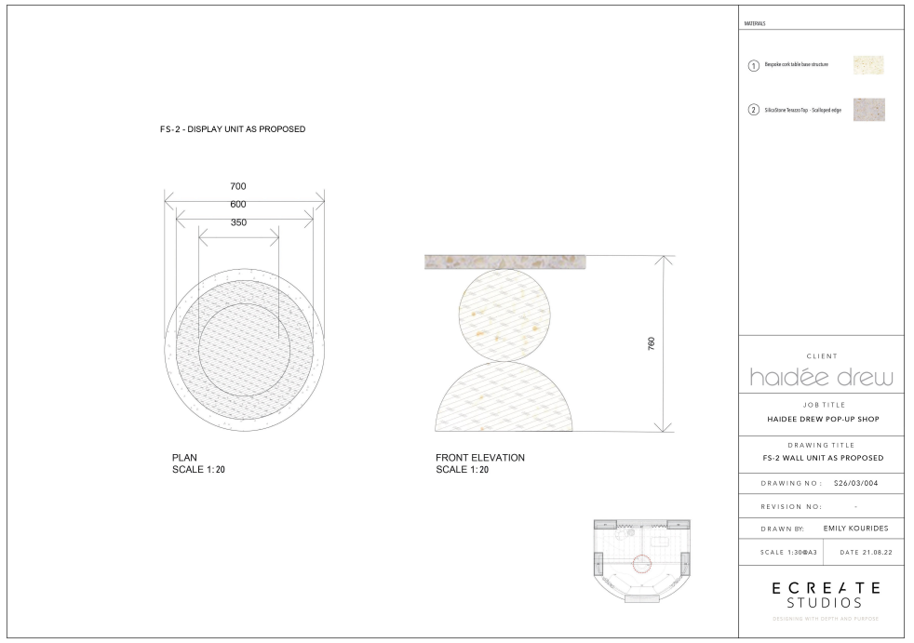

Fig .29 BAID, Drawings for custom-made display unit

To conclude, it is important to understand the significant role Technical Drawings play in an Interior design Project. Making sure you have a solid understanding of the types of Technical Drawings, will assist in understanding which ones are necessary for the Project you are working on, in order to provide the appropriate information for all the stakeholders of the project.